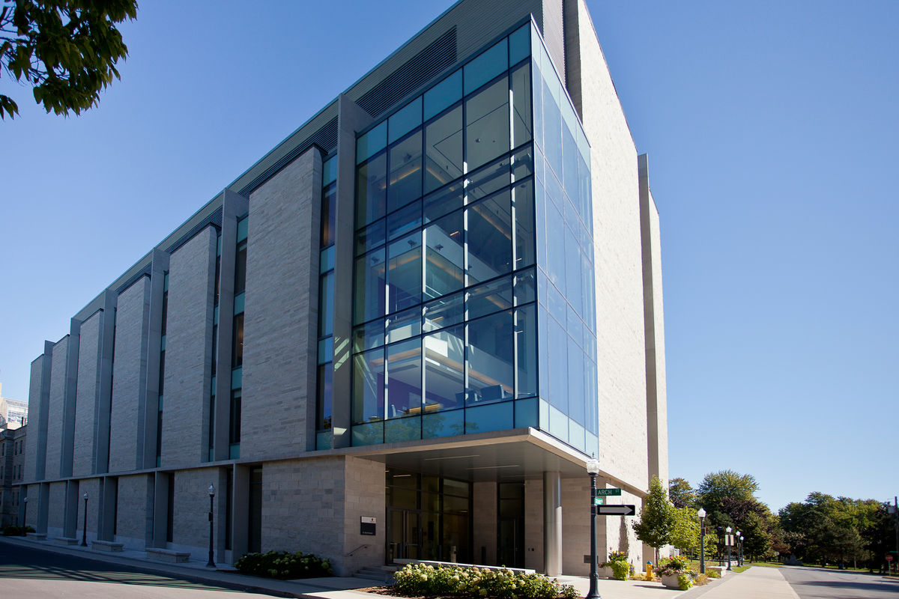



**M.AHAHBUDDIN**

**BATCH: 14**

**06/06/24**

**HYDRA**

**Hydra Pharmaceuticals PLC**

**Table of content**

**A brief history of HYDRA 2**

**Objective 2**

**1. Products and Services 2**

**2. Business plan 3**

**3. Sales and cost statistics 5**

**4. Corporate Values: 5**

**Social: 6**

A brief history of HYDRA

HYDRA today symbolizes a name – a state of mind. But its journey to growth and prosperity has been no bed of roses. From its inception in 2020, it has today burgeoned into one of the top-line conglomerates in Bangladesh. Hydra Pharmaceuticals Ltd., the flagship company, has held a strong leadership position in the pharmaceutical industry of Bangladesh since 2020 and is now on its way to becoming a high-performance global player.

HYDRA Pharmaceuticals PLC is the largest pharmaceutical company in Bangladesh and it has been continuously in the 1st position among all national and multinational companies since 2022. It was established in 2020 and converted into a public limited company in 2021.

**Objective**

Our objectives are to conduct transparent business operations based on market mechanisms within the legal & social framework with the aims of attaining the mission reflected by our vision.

# Products and Services

**Hydra** group has more than 150 types of medicine under the three types of products named are …..

* Pharma product (Acetram, Amikacin,Alatrol)
* Herbal & Nutraceuticals product (Adovas, AmCivit, Arubin**)**
* Agrovet & Pesticides product(Ampicin-Vet, AQUA PURE ® Powder, Almex-Vet® Bolus)

[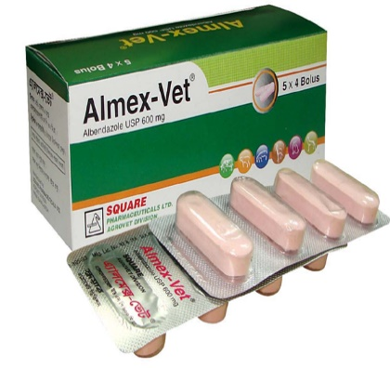](https://www.squarepharma.com.bd/product-details.php?pid=465) [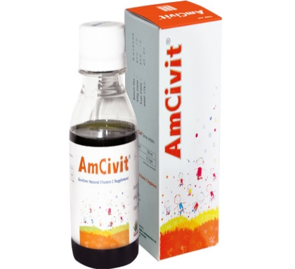](https://www.squarepharma.com.bd/product-details.php?pid=404)

[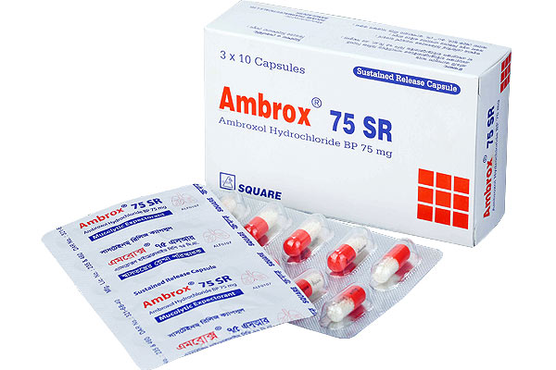](https://www.squarepharma.com.bd/product-details.php?pid=249) [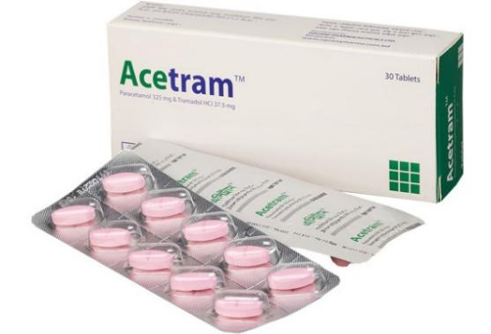](https://www.squarepharma.com.bd/product-details.php?pid=149)

Our vision is to create value and impact in society by way of improving quality of life and ensuring well-being of people. These product are available in our HYDRA Pharmaceuticals PLC.

# Business plan

The Primary objective of the study is to find out the management practices followed by HYDRA pharmaceuticals limited. The secondary objectives of this study are:

* To present an overview of the Square Pharmaceuticals Ltd.
* To analyze the performance through the flow of time.
* To Understand the efficiency within pharmaceuticals in Bangladesh
* To analyze the performance through the flow of time.
* To Understand the efficiency within pharmaceuticals in Bangladesh
* To identify and analyses Square Pharmaceuticals Ltd‘s strategies and

management policies

Hydra Pharmaceuticals Limited is an organization with equal emphasis on Leadership, Technology, Quality and Passion. Hydra Pharmaceuticals Ltd. is the leading branded generic pharmaceutical manufacturer in Bangladesh producing quality essential and other ethicaldrugs and medicines. Our mission is to achieve higher efficiency to develop and deliver affordable products and services to society for good.

6 Steps to start a medicine Business

Raw materials

Manufacturing & processing units

Medicine service Distribution

International Shippers

Retail Distributer

pharmacy

Clinic & hospital

International Dealing

**Fig: Flow chart of medicine supply**

# Sales and cost statistics

|  |  |  |  |  |
| --- | --- | --- | --- | --- |
| Yearly Report | | | | |
| Month | Expenses | Sales | Profit |
| January | 9288500 | 8750000 | -538500 |
| February | 9744300 | 9920000 | 175700 |
| March | 8904700 | 10000000 | 1095300 |
| April | 7345200 | 7957400 | 612200 |
| May | 8987000 | 9876500 | 889500 |
| June | 5215400 | 5164500 | -50900 |
| July | 9976500 | 11543600 | 1567100 |
| August | 7976700 | 8087900 | 111200 |
| September | 9879000 | 9969800 | 90800 |
| October | 6234800 | 7024000 | 789200 |
| November | 4534800 | 4809300 | 274500 |
| December | 8348700 | 8834800 | 486100 |

# Corporate Values:

* We are in society as a corporate citizen to strengthen the communities and neighborhoods by integrating them in the process of development.
* We care about maintaining environmental sustainability and preserving mother-nature ecosystem for a healthier planet.
* We are in business for economic success for advancing the world towards more viable solutions, products and services.

Corporate Headquarters:

HYDRA Centre, 48 Bir Uttam AK Khandakar Road,

Barishal-8200,Bangladesh.

Phone: 01533875711

****Email:info@hydra.com

**Social:**